A Project Report on



Submitted By:

Name of Student :
Registration no : 410005
Date of submission :

Under the guidance of Miss.Munmun Pandey submitted in partial
fulfillment of the requirement for qualifying.

Name and Address of the Accredited Centre:

I take this opportunity to express my sincere thanks and deep gratitude towards Miss. Munmun Pandey for her valuable guidance and co-operation in carrying out this Project successfully. Development of project like “TELEPHONE BILLING SYSTEM” in Visual Basic 6.0 is not a too much difficult task but fairly a puzzle one.
This language teaches so much about database programming and new Visual Basic 6.0.This project is a part of our DOEACC ‘A’ Level course. I have developed this project with the help of Faculty members of my Institute ISIT, Bokaro Steel City, and Jharkhand and as such I am extremely grateful to all of them. I am obliged to my project guide Miss. Munmun Pandey .

Name
Course :
Registration no:

Registration no : 410005

Name and Address of Accredited Centre:
ISIT
(Institute Of Science And Information Technology)
A DIVISION OF CYBER SYNERGY (P) LTD.
ISIT BLDG, H/B-1 CITY CENTRE, SECTOR-IV
BOKARO STEEL CITY (JHARKHAND)
PIN-827004
PHONE NO # 06542-231642

- Name of student :
- Address of student :

- Title of Project : TELEPHONE BILLING SYSTEM
- Name of guide : Miss. Munmun Panday
- Qualification of guide: M.Sc. (IT)

- Working / Teaching Experience of the guide : 1 years in ISIT

Signature of student Signature of guide

TO,
___________
___________

New Delhi
Respected Sir,

I am submitting my________project for evaluation. Details of my registration and postal address etc. are as under.

Registration no :
Name of student :
Father’s name :
Residential Address:

Email Address :

CHAPTERS: | PAGE NO :
1) Introduction | 7
i) Introduction of the Project | 8
ii) Objective of the Project | 9
2) System Analysis | 10
i) Introduction | 11-12
ii) Existing System | 13
iii) Drawback of the Existing System | 13-14
iv) Proposed System | 14
v) Objective and Advantage of Proposed System | 15
vi) Software Requirement Specification | 16
vii) Data Flow Diagram | 17-20
viii) Gantt Chart | 21
3) System Design | 22
i) Introduction | 23-24
ii) Design Strategy | 24-26
iii) Input Design | 25- 26
iv) Output Design | 26
v) Table Design | 27
4) Tools Chosen | 28
i) Proposed System Environment | 29
ii) About Front End | 30-34
iii) About Back End | 35-36
5) Source Code | 37-68
6) Input And Output Screen | 69-80
7) Testing And Debugging | 81-84
8) Scope And Result Discussion | 85-89
9) Bibliography | 89

Chapter – 1
Introduction

1) (i) INTRODUCTION OF THE PROJECT

The purpose of the project is to present the requirement of the Computerization of Telephone Billing System. The project thus calculates the telephone bills automatically. It does almost every work which is related to automatic telephone billing connection system via- new connection , customer record modification, viewing customer records & all works related to rate of bills, meter readings in addition to bill calculation and bill generation. “Telephone Billing System ” is developed as per seeing the increasing requirement to speed up the work and incorporate a new work culture. Thus a new software has been proposed to reduce manual work, improving work efficiency, saving time and to provide greater flexibility and user-friendliness as the system previously followed was totally manual one with lots of errors.

1) (ii)OBJECTIVE OF THE PROJECT

The main objective while implementing the project Telephone Billing System were to minimize the work and at the same time increase the speed of the work done.

This new system is built with the following objective:

- Information retrieval will become easy.
2) Maintenance of database as well as overall project will become easy.
3) Security measure will be adopted, by maintaining the login of username and the password.
4) Data redundancy will be greatly reduced because this new system is built using Visual Basic 6.0 as front-end. It entails looking into duplication of efforts , bottlenecks and inefficient existing procedures

Chapter – 2
System Analysis

2) (i) INTRODUCTION

System analysis is the performance management and documentation of activities related to the four life cycle phases of any software namely:

- The Study Phase
- The Design Phase
- The Development Phase
- The Operators Phase

System analysis is a vast field of study through which system analyst puts his thoughts and searches for the solution of problem. He has to get a clear idea of what he has in hand and what he has to produce. He has to extract the essence of expectations. He has to satisfy the user in the very possible way. System analysis needs and should include the following steps of study:

- Study of current methods, the basic inputs available and output desired.
- The splitting of a variable inputs into (.dbf) files so as to reduce redundancy and increase consistency.
- Give the idea of key – field (if any) .
- Ideas regarding code generation.

Software Analysis starts with a preliminary analysis and later switches on to a detailed one. During the preliminary analysis the Analyst takes a quick look at what is needed and whether the cost benefits. Detailed analysis studies in depth all the cornered factors, which builds and strengthens the software.
A system study is a step-by-step process used to identify and then developed the software needed to control the processing of specific application. System study is also known as SDLC (Software Development Life Cycle).
Steps of SDLC are:
- Problem Definition

- Feasibility Study

- System Analysis

- System Design

- Implementation

- Post Implementation

- Maintenance

2) (ii) EXISTING SYSTEM
The existing system was a manual one. Whatever be the process involved in the system were done through register (files) . There were lots of complexities involved in the system. When any customer takes new connections then separate files were maintained. Updating of data was very tedious job. It was not easy to do several administrative works like managing rates of calls, addition or modification of metered calls & customer entries.

2) (iii) DRAWBACKS OF EXISTING SYSTEM

In the existing system all the office works was done manually. The manual work processes was time consuming and hence slow. Following are the main drawbacks of the existing system:

- The existing system is totally manual thus there are chances of error in processing.
- The basic and major drawbacks in the existing system are the speed of retrieval of data from files, which leads to delay.
- Maintenance of voluminous data is very cumbersome and laborious job.
- The manual jobs such as calculation are more error prone.
- There are plenty of chances of duplicity of data and information.

- Updating is very tedious job.
- There is no central database from where one can get different statistical data at one place.
The above facts, figures and drawbacks clearly indicate that there is need for computerization and thus decided to computerize the “TELEPHONE BILLING

SYSTEM”. Since the existing system was totally manual which has lots of complexities, shortcomings in itself and all the data was being stored in registers, files etc thus to overcome the limitation of the existing system, the new computerized system was needed, so that information can be provided to the user more quickly, easily and more accurately.
2)(iv) PROPOSED SYSTEM
The new system titled “TELEPHONE BILLING SYSTEM” was hence proposed to remove all the drawbacks discussed above.
Information is a vital ingredient for the operation and management of any organization. Thus any system should have the ability to provide error free filtered information after processing the required data. This system has been taken up with a view for developing a more sophisticated system that can be easily handled by any kind of users. The proposed system aims at efficient and timely information for decision-making, integrate with other functions, and reduce redundant work.
Important features of this proposed system are:
- Consistent user interface with high economic features built into it.
- System design in modular and structured way so as to make the integration with other subsystems easier.
- User has complete control as it provides and accept only appropriate and valid data.
- User-friendly error messages are provided wherever necessary.
- Addition, deletion, modification of records as when needed.
- Providing connections to new customers.
- Bill generation for customers.

2) (v) OBJECTIVES OF THE PROPOSED SYSTEM

- To reduce workload of staff.
- To reduce the delay in processing time.
- To reduce the delay in bill generation.
- To provide the user-friendliness in all possible ways.
- To provide greater flexibility.
- Make maintenance changes easy.
- To store data in a centralized location to reduce redundancy and increase consistency.

2) (vi) SOFTWARE REQUIREMENT SPECIFICATION

SRS (Software Requirement Specification) is a document that completely describes what the proposed should do, without describing how the software does it.
PURPOSE : The purpose of the project is to develop a system which is user friendly, easy to use , maintain and satisfies all the requirements of the user.

PERFORMANCE REQUIREMENT
- The operation time should be small and the throughput should be high.
- It should produce timely and accurate result.

SOFTWARE QUALITY ATTRIBUTES

- Maintainability – Since it is directly associated with the database, so there is very little maintainability problem with this tool.
- Portability – Since there is very limited usage of separate forms, this tool is very much portable. This tool uses several canvases on the same form.
- Flexibility – This tool is very much flexible for future enhancements.

2) (vii) DATA FLOW DIAGRAM

- CONTEXT DIAGRAM

CUSTOMER RECORDS
AND RATES

ADMINISTRATOR

TELEPHONE

BILLING

SYSTEM

GENERATED BILL

CUSTOMER

- FIRST LEVEL DATA FLOW DIAGRAM

1

Login Verification
Input Username And Password

Valid User
New Customer Details
New Customer
2

Processing of new customer information
Customer Details
(Master File)
Details

(table 1)

Input Ratings
Rate Maintenance
3

Processing of ratings for different types of calls

ADMINISTRATOR

( table 2)
Ratings

4

Verification of valid customer and processing of minute reading
Input Meter / Minute Reading For Valid
Customer
Customer
Number
Minute reading ( table 3)
Customer Minute Details

FIRST LEVEL DATA FLOW DIAGRAM
(continued)

Valid customer number

and Minute details

Ratings
5

Generation of Bill
Generated
Bill

Rate Maintenance
User
Customer Name And Address

Customer Details
(Masterfile)

- SECOND LEVEL DATA FLOW DIAGRAM

Here “Process 5” is exploded, since it is required to show its further details.
5.1

Minute Reading is multiplied with corresponding rating
Valid customer no. & minute details

Customer Minute Details

Ratings
( table 3)

Multiplied Result
5.2

Multiplied Result is inserted in table
Rate Maintenance
( table 2) Multiplied Result

Customer Bill Details
( table 4)

Individual Bills for each call
5.3

Bill is generated, using this multiplied result, monthly rental, getting the sum with customer name & address
types
Monthly Rental

Customer Name & Address

Customer Details
( Master file)
Generated Bill

2) (viii) PROJECT PLANNING AND SCHEDULING

- GANTT CHART

Problem Statement
& Analysis

Feasibility Study

Logical & Conceptual
System Designing

Coding, Testing &
Documentation

1 Jun’07 20 Jun’07 10 Jul’07 30 Jul’07 20 Aug’07

Chapter – 3
System Design

3) (i) INTRODUCTION

System design is the second step in the system life cycle, in which overall design of the system is achieved. The functionalities of the system is designed and studied in this phase. The first step is designing of program specification. This determines the various data inputs to the system, data flow and the format in which output is to be obtained.
Design phase is a transmission phase because it is a transition from user oriented document to computer data. The activity in the design phase is the allocation of functions to manual operations, equipment and computer programs. Flow charts prepared in the study time received and decomposed until all functions in the system perform evidently.
Design is a multistep process that focuses on data structures, software architecture, procedural details( algorithms etc) and links between the modules. The design process goes through logical and physical stages. In logical design reviews are made linking existing system and specification gathered. The physical plan specifies any hardware and software requirement, which satisfies the local design.
Modularization of task is made in the mode. The success of any integrated system depends on the planning of each and every fundamental module. Usually a project is revised in step by step sequence. Inter phase management of such module is also important.Software design methodology changes continually as new methods, better analysis and broader understanding evolve.
Various techniques for software design do exit with the availability of criteria for design quality. Software design leads three technical activities-design, code and test.
The techniques for software design do exit with the availability of criteria for design quality. Software design leads three technical activities-design, code and test that are required to build and verify software. Each activity transforms information, which validates the software. The design system converts theoretical solution introduced by the feasibility study into a logical reality.
3)(ii) DESIGN STRATEGY

The design strategy is a vital aspect of the system to be developed. The design of the software reflects the basic understanding of the problem. For designing a good system what we have to be is to get correct definition of the problem and analyze the problem thoroughly.
The design of a system should be such that if a small portion is changed. The rest of the system should be unaffected. This is the flexibility of the system. Greater the system flexibility greater will be the system reliability. While carrying out the job of designing of a new system one has to consider many factors. These factors include the drawbacks and limitations of the present manual system as well as of the features and advantages of the proposed system. It should be designed in such a manner that even a layman can run it without any difficulty.

An important quality of a software must enjoy is “user friendliness”. It can be achieved in many ways like providing menu, giving context sensitive help, doing automatic validation to input data, etc. Another main factor is speed efficiency. In order to achieve speed efficiency, the program should be designed accordingly and the user is provided with a compiled copy of the software package with necessary data file format rather than source code.
Design of input and output formats is equally important for any design. The output format should be designed in such a way that it must reflect all the required information in detail. The design of the database itself such as type of data stored, size of data etc. Some of the decisions made during database design are:
- Which data items are to be recorded and in which database.
- Length of each record, based on the characteristics of the data items on which it is based.
- Data who’s unauthorized change must be prevented.
- Data, which must be avoided from redundancy.
- Maintenance of data integrity etc.
- Avoid over writings.
- Prevents invalid data access and changes.
Having all this, a positive interaction with clients at every stage of development is the core around which the software is built.

3) (iii) INPUT DESIGN

Input design is the process of converting user-originate inputs to a computer-based format. The goal of design input data is to make data entry as easy, logical and free. The most common source of data processing errors is inactive input data. Effective design of the input data minimizes the error made by data entry operators. Catching errors on input is far less costly than correcting after data storage is complete.
User-friendly input design enables quick error detecting and correction. Verification and validation is the most important in input design. Since the system is used interactively, it has two types of inputs. Interactive input-which is the point contact of the user with the system and the input to the internal system i.e. Databases. For full efficiency of the system, it is necessary that the input must be accurate. Since the user of the system may not be a technical person and may not know input concepts so it is required that he warn, prevent and correct invalid data entry.
There are many ways that can be designed to handle such a situation. We can prevent the user entering invalid data into the databases by warning, neglecting or messaging appropriately. The user is then allowed to input correct data. Some help provisions may aid the user to point out the error. In this system inputs are collected from terminals through keyboard.
3) (iv) OUTPUT DESIGN
Output design has been an ongoing activity from the very beginning of the project. The objective of the output design is to convey the information of all past activities, current status and to emphasize important events. The output generally refers to the results and information that is generated from the system.
The output design of the system is accomplished keeping in mind the following activities:
- Determine what information is to display.
- Decide whether to display or print the information retrieved, processed, generated from the system.
- Arrange the presentation of information in an acceptable format.
- Decide how to distribute the output to the intended recipients.

In the output design phase one or more output media can be selected. Out of which the most common ones are CRT displays and print out. Here only CRT display has been attempted. A rapid enquiry is obtained from CRT displays. From design is made interesting and attractive. Easy understanding and effectiveness is made possible.

- (v) TABLE DESIGN
Field Name
Data Type

1. CUSTOMER_RECORDS
custname | Text
custadd | Text
custphno | Number
2. CALL_RATES
local | Number
mobile | Number
STD | Number
ISD | Number
MonthlyRental | Number
3. CUSTOMER_METER_READING
custphno | Text
mLocal | Number
mmobile | Number
mSTD | Number
mISD | Number
4. BILL_RECORD
custname | Text
custphno | Text
custadd | Text
localmt | Number
mobilemt | Number
STDmt | Number
ISDmt | Number
5. LOGIN
LOGIN_ID | AutoNumber
LOGIN_NAME | Text
LOGIN_PASSWORD | Text

Chapter – 4
Tools Choosen

4) (i) PROPOSED SYSTEM ENVIRONMENT

The system environment can be classified into two categories –
- Hardware environment
- Software environment

Hardware Environment

- The application front-end (client) will be designed on machines with Windows 98/ Window XP, Pentium III processors, 64/128 MB RAM.
- The database will be running on Windows OS, Pentium III processors, 64 MB RAM.

Mouse as pointing device.

Software Environment

- The application front end will be designed using Visual Basic 6.0.
- The database has been designed on Microsoft Access (Office Package).

4) (ii) ABOUT FRONT END

MICROSOFT VISUAL BASIC 6.0
Visual Basic 6.0 is an enjoyable language due to its visual environment. Building a windows program in Visual Basic requires dragging and dropping graphic objects on to the screen from a toolbox. Thus Visual Basic is the efficient GUI tools to develop some exciting windows-based application.
Visual Basic 6.0 is much more than just a programming language. The programming language forms the background of all that takes place in a running Visual Basic program. The language is a secondary consideration to the user interface. A windows program offers a high degree of user interaction using the graphical elements that forms the objects on the window the user sees .If the user interface is not correct, user will not like the program.
Visual Basic lets one add menus, text boxes, command buttons, option buttons (for making exclusive choice), check boxes, list boxes, scroll bars and file and directory boxes to black windows. One can use Visual Basic to communicate with other applications, running under windows. Visual Basic offers: More Internet features, better support for data base development, more language feature to make programming job easier.

SOME TOOLS OF VISUAL BASIC 6.0

- Data access features allow creating databases, front-end applications and scalable server side components for most popular databases formats including Microsoft SQL server and other enterprise level databases.
- Active X technology allows using functionality provided by other applications such as Microsoft Word, Microsoft Excel and other applications and objects could be created using the Professional Enterprise editions of Visual Basic.
- Internet capabilities make it easy to provide access to documents and applications across the Internet or Intranet server applications.
The finished applications are a true .exe files that uses a Visual Basic virtual machine that can be freely distributed.
SIGNIFICANCE FEATURES OF VISUAL BASIC 6.0

Toolbox: The Tool Box window differs from the tool bar. The Tool Box is a collection of tool that acts as a repository of controls we can place on forms. Some tools are Selection Pointer, Picture Box, Label, Text Box, Frame Button, Command Botany, Check Box, Option Button etc.
Form: Visual Basic uses a window; controls are the widgets one place of a form. In a form we will customize by adding controls such as command buttons, list boxes to it. At the top of the black form is the little bar with its caption.
Common Form properties:
There are several common properties to customize a form, these are: -
Caption: Caption is used as a title that the Microsoft Window for the application icon when the user minimizes the application.
Name: This property is used to give the name that one want to use to refer to the form.

Enabled: If user sets Enabled to false, the form cannot respond to any events such as the user checking on the form.
Icon: The icon property determines the icon users application will display when it is minimized on tool bar or turned into a stand-alone application on windows desktop.
Visible: If the value of the property is set to false, it will no longer be visible.

Text Boxes:
It is used to display text or to accept user input. Most of the code is written to process the information users enter into them. Several properties of text boxes are as follows: -
Text: The text property in text box is the analog of the caption property for a command button or a form; it controls text the users see. It determines whether text on the control such as label or command button, is left justified, centered, or right justified on the control. The Alignment property take one of the three values: 0-Left justify, 1-Right justify, 2-Center.
Multiline: This property determines whether a text box can accept more than one line of text when the user runs the application, and it is usually combine with resulting the value of the scrollbar property. If true the property specifies the text box can hold more than a line of text.
Max Length: This property specifies the maximum number of characters that the text box will accept. A value of 0 indicates that the user can enter a value of any length.

Locked: This property determines whether the user can enter a value or change the default value of the text box. If true, the user cannot change the text box value until the program, at run time assigns a false to this property.
Password char: The Password property lets us limit what the text box displays.
Labels: Use Labels to display information programmer does not want the user to be able to change. Most common use for Labels is to identify a text box or other control by describing its contents. Another common use is to display help information.
Message Boxes:
Message boxes display information in the dialog box superimposed on the form. They want for the user to choose a button before return to the application. User cannot switch to another form in programmers applications as long as Visual Basic is displaying a message box.

Value Named constant Description
0 vbOKOnly OK button
1 vbOKCancel OK and Cancel buttons
2 vbAboRetryIgnore Abort,Retry and Cancel buttons
3 vbYesNoCancel Yes and No and Cancel buttons
4 vbYesNo Yes and No buttons
MsgBox “ The message goes in codes”, 4
Frames:
Programmer usually frames passively to group images or controls.

Option Buttons:
They all work together. When the user chooses one button, all other buttons in the group are turned off. The value property of the option button tells us whether a button was selected by the user. If the value property is true, the user selected that button; otherwise, its value property is false.
Check Boxes:
Check Boxes differ from option button in that, regardless of how many Check Boxes one places on a form, they can all be turned on and off independently. If the user has selected Check Boxes, the value property switches to true. It stays true until the user deselects that box.
List and Combo boxes:
Use list boxes when we have a fixed list of choices. Visual Basic automatically adds vertical scroll bars when the list box is small for all items it contains.
To allow users to input data as well as choices from a list, we use a Combo Box.

FOLLOWING ARE THE CUSTOM CONTROLS, WHICH ARE ALSO DATA AWARE:
- Data List
- Data Combo
- Data Grid
- Microsoft Flex Grid
- Microsoft Hierarchical Flex Grid
- Rich Textbox
- Microsoft Chart
- Date Time Picker
- Image Combo

4) (iii) ABOUT BACK END

MICROSOFT ACCESS

Database: -A database is a set of data, organized for easy access. The database is the actual data. It is the database that you will be accessing when you need to retrieve data.
Data Dictionary: -The data dictionary is a set of tables Access uses to maintain information about the database. The data dictionary contains information about tables, indexes, clusters, and so on.
DBA (Database Administrator): -The DBA is the person responsible for the operation, configuration, and performance of the database. The DBA is charged with keeping the database operating smoothly, ensuring that backups are done on a regular basis (and that the backups work), and installing new software. Other responsibilities might include planning for future expansion and disk space needs, creating databases and tablespaces, adding users and maintaining security, and monitoring the database and retuning it as necessary. Large installations might have teams of DBAs to keep the system running smoothly; alternatively, the tasks might be segmented among the DBAs.

DBMS or RDBMS: -The Database Management System is the software and collection of tools that manages the database. Access software is the DBMS. A Relational Database Management System is a DBMS that is relational in nature. This means that the internal workings access data in a relational manner. Access is an RDBMS.
Query: -A query is a read-only transaction against a database. A query is generated using the SELECT statement. Users generally distinguish between queries and other transaction types because a query does not change the data in the database.
Schema: -A schema is a collection of objects associated with the database.
Microsoft Access is a very effective DBMS tool which is generally used by all the users. It is compatible with all types of systems & can be installed and used as and when required.

Chapter – 5
Source Code

5) SOURCE CODE

*******************Code For Start Form*******************

Dim i As Integer

Private Sub Form_Load()
start.Show
Timer1.Enabled = True

ProgressBar1.Value = 0
i = 0
Shape1(i).BackColor = "&HC00000"
i = i + 1
ProgressBar1.Scrolling = ccScrollingSmooth
End Sub

Private Sub Timer1_Timer()
ProgressBar1.Value = ProgressBar1.Value + 2
If ProgressBar1.Value Mod 20 = 0 Then
Shape1(i).BackColor = "&HC00000"
i = i + 1
End If
If ProgressBar1.Value = 100 Then Timer1.Enabled = False: Unload start1: Unload Me: frmopt.Show
End Sub

*******************Code For Start1 Form*******************

Private Sub Form_GotFocus()
start.Show

End Sub

Private Sub Timer1_Timer()
r = Rnd * 150
g = Rnd * 200
b = Rnd * 150
Label1.Forecolor = RGB (r , g , b)
Label2.Forecolor = RGB (r , g , b)
End Sub

*******************Code For Login Form*******************

Option Explicit
Public LoginSucceeded As Boolean
Private Sub cmdcancel_Click()
LoginSucceeded = False
Me.Hide
frmopt.Show
End Sub

Private Sub cmdok_Click()
If txtPassword = "teleproject" And txtUserName = "poonam" Then
LoginSucceeded = True
MDIForm1.Show
Unload Me
Unload frmopt
Unload frmLoginbase
Else
MsgBox "Invalid Password, try again!", , "Login"
txtPassword.SetFocus
SendKeys "{Home} + {End}"
End If
End Sub

*******************Code For (frmopt) Form*******************

Private Sub cmdenter_Click()
frmLoginbase.Show
frmLogin.Show
Me.Hide
End Sub

Private Sub cmdexit_Click()
End
End Sub

Private Sub cmdhelp_Click()
frmAbout.Show
Me.Hide
End Sub

Private Sub Form_Load()
Unload start1
Unload start
End Sub

Private Sub Timer1_Timer()
r = Rnd * 200
g = Rnd * 100
b = Rnd * 150
Label1.ForeColor = RGB(r, g, b)
Label5.ForeColor = RGB(r, g, b)
Label6.ForeColor = RGB(r, g, b)
End Sub

Private Sub Timer3_Timer()
r = Rnd * 100
g = Rnd * 150
b = Rnd * 200

Label2.ForeColor = RGB(r, g, b)
Label3.ForeColor = RGB(r, g, b)
Label4.ForeColor = RGB(r, g, b)
End Sub

*******************Code For (MDIForm1) Form*******************

Option Explicit

Private Sub about_Click()
frmAbout.Show
End Sub

Private Sub exit_Click()
Unload Me
frmopt.Show
End Sub
Private Sub mnucb_Click()
frmbill.Show
End Sub

Private Sub newcon_Click()
frmnew.Show
End Sub

Private Sub option_Click()
frmoptad.Show
End Sub

Private Sub viewrec_Click()
frmrec.Show
End Sub

**********Code For frmnew called by MDIForm1 Form**********

Option Explicit

Dim rs As Recordset
Dim con As Connection
Private Sub err_han()
Dim response As Integer
Select Case Err.Number
Case -2147467259
Call EDTB(Empty)
Call EmptyTB
MsgBox "Duplicate Record Entry", vbInformation + vbOKOnly, "TELEBILL SOFTWARE"
Case Else
If Err.Number <> 0 Then
MsgBox Err.Number & " : " & Err.Description
End If
End Select
End Sub

Private Sub cmdadd_Click()
On Error GoTo error_handler
If Text1.Text <> Empty Or Text2.Text <> Empty Then
con.Execute "insert into table1 values('" & Text1.Text & "','" & Text3.Text & "','" & Text2.Text & "')"
MsgBox "Records Inserted Successfully", vbInformation + vbOKOnly, "TELEBILLING SOFTWARE"
Else
MsgBox "Check for Empty Boxes", vbInformation + vbOKOnly, "TELEBILLING SOFTWARE"
End If

Call EmptyTB
Call EDTB(False)
error_handler:
err_han
End Sub

Private Sub cmdback_Click()
Me.Hide
MDIForm1.Show
End Sub

Private Sub Form_Load()
Set con = New Connection
con.Open "Provider=Microsoft.Jet.OLEDB.4.0;Data Source='C:\Poonam\tele.mdb';Persist Security Info=False"
End Sub

Public Function EDTB(cho As Boolean)
Text1.Enabled = cho
Text2.Enabled = cho
Text3.Enabled = cho
End Function

Public Sub EmptyTB()
Text1.Text = Empty
Text2.Text = Empty
Text3.Text = Empty
End Sub

**********Code For frmrec called by MDIForm1 Form**********
Option Explicit
Dim rs As Recordset
Dim rs1 As Recordset
Dim con As Connection
Private Sub err_han()
Dim response As Integer
Select Case Err.Number
Case 3021
Text1.Text = rs.Fields(0)
Text2.Text = rs.Fields(2)
Text3.Text = rs.Fields(1)
Text4.Text = 0
Text5.Text = 0
Text6.Text = 0
Text7.Text = 0
Case Else
If Err.Number <> 0 Then
MsgBox Err.Number & " : " & Err.Description
End If
End Select
End Sub

Private Sub cmdexit_Click()
Call Clear
Call EDCmd(True)
Me.Hide
MDIForm1.Show
End Sub

Private Sub cmdok_Click()
Dim match As Boolean
match = False
rs.MoveFirst
Do While Not rs.EOF
If LCase(Left(rs.Fields(0), 1)) = LCase(Text8.Text) Then
match = True
Exit Do

Else
rs.MoveNext
End If
Loop
If match = False Then
MsgBox "No such record is there!!!", vbInformation + vbOKOnly, "TELEBILL SOFTWARE"
rs.MoveFirst
Else
Call LocateMtr
Call Display
End If
End Sub

Private Sub cmdpre_Click()
If rs.BOF Then
MsgBox "No more records!!!", vbInformation + vbOKOnly, "TELEBILL SOFTWARE"
rs.MoveNext
Else
rs.MovePrevious
End If
If Not rs.BOF Then
Call LocateMtr
Call Display
Else
Call Clear
End If
End Sub

Private Sub cmdnext_Click()
If rs.EOF Then
MsgBox "End of record!!!", vbInformation + vbOKOnly, "TELEBILL SOFTWARE"
rs.MovePrevious
Else
rs.MoveNext
End If
If Not rs.EOF Then
Call LocateMtr
Call Display
Else
Call Clear
End If
End Sub

Private Sub cmdfirst_Click()
rs.MoveFirst
Call LocateMtr
Call Display
End Sub

Private Sub cmdlast_Click()
rs.MoveLast
Call LocateMtr
Call Display
End Sub

Private Sub Form_Activate()
Set con = New Connection
con.Open "Provider=Microsoft.Jet.OLEDB.4.0;Data Source='C:\Poonam\tele.mdb';Persist Security Info=False"
Set rs = New Recordset
Set rs1 = New Recordset
rs.Open "select * from table1 order by custname", con, adOpenDynamic, adLockOptimistic
rs1.Open "select * from table3 ", con, adOpenDynamic, adLockOptimistic
If Not rs.BOF Then
Call LocateMtr
Call Display

Else
Call EDCmd(False)
End If
End Sub

Public Function Display()
On Error GoTo error_handler
Text8.Text = "a"
Text1.Text = rs.Fields(0)
Text2.Text = rs.Fields(1)
Text3.Text = rs.Fields(2)
Text4.Text = rs1.Fields(1)
Text5.Text = rs1.Fields(2)
Text6.Text = rs1.Fields(3)
Text7.Text = rs1.Fields(4)
error_handler:
err_han
End Function

Public Function Clear()
Text1.Text = ""
Text2.Text = ""
Text3.Text = ""
Text4.Text = ""
Text5.Text = ""
Text6.Text = ""
Text7.Text = ""
End Function

Public Function LocateMtr()
On Error GoTo error_handler
rs1.MoveFirst
Do While Not rs.EOF
If rs.Fields(2) = rs1.Fields(0) Then
Exit Function
End If
rs1.MoveNext
Loop
error_handler:
err_han
End Function

Public Function EDCmd(choice As Boolean)
cmdok.Enabled = choice
cmdfirst.Enabled = choice
cmdpre.Enabled = choice
cmdnext.Enabled = choice
cmdlast.Enabled = choice
End Function

**********Code For frmbill called by MDIForm1 Form**********

Option Explicit
Dim con As Connection
Dim rs As Recordset
Dim sum1 As Double
Dim sum2 As Double
Dim sum3 As Double

Private Sub Combo1_Change()
Dim reco As Recordset
Set reco = New Recordset
reco.Open "select * from table1 where custphno='" & Combo1.Text & "'", con, adOpenDynamic, adLockOptimistic
If Not reco.EOF Then
txtname.Text = reco!custname
txtadrs.Text = reco!custadd
End If
Set reco = Nothing
Dim pp As Recordset
Set pp = New Recordset
pp.Open "select * from table3 where custphno='" & Combo1.Text & "' ", con, adOpenDynamic, adLockOptimistic
If Not pp.EOF Then
txtmtrlocal.Text = pp!mlocal
txtmtrmobile.Text = pp!mmobile
txtmtrstd.Text = pp!mSTD
txtmtrisd.Text = pp!mISD
Else
txtmtrlocal.Text = Empty
txtmtrmobile.Text = Empty
txtmtrstd.Text = Empty
txtmtrisd.Text = Empty
End If
Set pp = Nothing
End Sub

Private Sub Combo1_Click()
Dim reco As Recordset
Set reco = New Recordset
reco.Open "select * from table1 where custphno='" & Combo1.Text & "'", con, adOpenDynamic, adLockOptimistic
If Not reco.EOF Then
txtname.Text = reco!custname
txtadrs.Text = reco!custadd
End If

Set reco = Nothing
Dim pp As Recordset
Set pp = New Recordset
pp.Open "select * from table3 where custphno='" & Combo1.Text & "' ", con, adOpenDynamic, adLockOptimistic

If Not pp.EOF Then
txtmtrlocal.Text = pp!mlocal
txtmtrmobile.Text = pp!mmobile
txtmtrstd.Text = pp!mSTD
txtmtrisd.Text = pp!mISD
Else
txtmtrlocal.Text = Empty
txtmtrmobile.Text = Empty
txtmtrstd.Text = Empty
txtmtrisd.Text = Empty
End If
Set pp = Nothing
End Sub

Private Sub DTPicker1_Change()
If (DateValue(Date) - DateValue(DTPicker1.Value)) > 0 Then
MsgBox "Invalid Entry Plz Enter Again, Thank U!!!", vbCritical + vbOKOnly, "TBS SOFTWARE"
DTPicker1.Value = Date
End If
End Sub

Private Sub Form_Activate()
Set con = New Connection
con.Open "Provider=Microsoft.Jet.OLEDB.4.0;Data Source='C:\Poonam\tele.mdb';Persist Security Info=False"
Set rs = New Recordset
rs.Open "select custphno from table1 group by custphno", con, adOpenDynamic, adLockOptimistic
Combo1.Clear
Do While Not rs.EOF
Combo1.AddItem (rs!custphno)
Combo1.Text = rs!custphno
rs.MoveNext

Loop
Set rs = Nothing

Dim kk As Recordset
Set kk = New Recordset
kk.Open "select * from table2", con, adOpenDynamic, adLockOptimistic
If Not kk.EOF Then
txtlocal.Text = kk!Local
txtmobile.Text = kk!Mobile
txtstd.Text = kk!STD
txtisd.Text = kk!ISD
txtmonrent.Text = kk!MonthlyRental
Else
MsgBox "No Pulse rate entry!!!", vbInformation + vbOKOnly, "TBS SOFTWARE"
Me.Hide
Set kk = Nothing
Exit Sub
End If
Set kk = Nothing
DTPicker1.Value = Format$(Now, "dd-MMM-yyyy")
Call EmptyTB
End Sub

Public Function TotalBill()
txttotlocal.Text = Val(txtlocal.Text) * Val(txtmtrlocal.Text)
txttotmobile.Text = Val(txtmobile.Text) * Val(txtmtrmobile.Text)
txttotstd.Text = Val(txtstd.Text) * Val(txtmtrstd.Text)
txttotisd.Text = Val(txtisd.Text) * Val(txtmtrisd.Text)
sum1 = Val(txttotlocal.Text) + Val(txttotmobile.Text) + Val(txttotstd.Text) + Val(txttotisd.Text)
txttot.Text = "Rs. " & sum1
sum3 = Val(txtmonrent.Text)
sum2 = sum1 * 0.08
txttax.Text = "Rs. " & Int(sum2)
txttot1.Text = "Rs. " & Int(sum1 + sum2 + sum3)
txtdue.Text = "Rs. " & Int(sum1 + sum2 + sum3 + 50)
End Function

Private Sub lblbill_Click()
con.Execute "delete from table4"
con.Execute "insert into table4 values ('" & Combo1.Text & "','" & txtname.Text & "','" & txtadrs.Text & "','" & Val(txttotlocal.Text) & "','" & Val(txttotmobile.Text) & "','" & Val(txttotstd.Text) & "','" & Val(txttotisd.Text) & "')"

Dim reco As Recordset
Set reco = New Recordset
reco.Open " select * from table4", con, adOpenDynamic, adLockOptimistic
If Not reco.EOF Then

With DataReport1
Set .DataSource = reco
.Sections("section1").Controls.Item("lbltelno").Caption = Combo1.Text
.Sections("section1").Controls.Item("lblname").Caption = txtname.Text
.Sections("section1").Controls.Item("lbladrs").Caption = txtadrs.Text
.Sections("section1").Controls.Item("lblmtrlocal").Caption = txtmtrlocal.Text
.Sections("section1").Controls.Item("lblmtrmobile").Caption = txtmtrmobile.Text
.Sections("section1").Controls.Item("lblmtrstd").Caption = txtmtrstd.Text
.Sections("section1").Controls.Item("lblmtrisd").Caption = txtmtrisd.Text
.Sections("section1").Controls.Item("lblmonrent").Caption = txtmonrent.Text
.Sections("section1").Controls.Item("lbltotlocal").Caption = "Rs. " & txttotlocal.Text
.Sections("section1").Controls.Item("lbltotmobile").Caption = "Rs. " & txttotmobile.Text
.Sections("section1").Controls.Item("lbltotstd").Caption = "Rs. " & txttotstd.Text
.Sections("section1").Controls.Item("lbltotisd").Caption = "Rs. " & txttotisd.Text
.Sections("section1").Controls.Item("lbltot").Caption = txttot1.Text

.Sections("section1").Controls.Item("lbltax").Caption = txttax.Text
.Sections("section1").Controls.Item("lblafterdate").Caption = txtdue.Text
.Sections("section1").Controls.Item("lbldate").Caption = Format$(DTPicker1.Value, "dd-MMM-yyyy")
.Show
End With
End If
Set reco = Nothing
End Sub

Private Sub lblexit_Click()
Me.Hide
MDIForm1.Show
End Sub

Private Sub txtmtrlocal_Change()
Call TotalBill
End Sub

Private Sub txtmtrmobile_Change()
Call TotalBill
End Sub

Private Sub txtmtrstd_Change()
Call TotalBill
End Sub

Private Sub txtmtrisd_Change()
Call TotalBill
End Sub

Public Function EmptyTB()
Combo1.Text = Empty
txtname.Text = Empty

txtadrs.Text = Empty
txtmtrlocal.Text = Empty
txtmtrmobile.Text = Empty
txtmtrstd.Text = Empty
txtmtrisd.Text = Empty
End Function

**********Code For frmoptad called by MDIForm1 Form**********

Private Sub cmdback_Click()
Unload Me
MDIForm1.Show
End Sub

Private Sub cmdok_Click()
If Option1.Value Then frmmtrentry.Show: frmoptad.Hide
If Option2.Value Then frmratentry.Show: frmoptad.Hide
If Option3.Value Then frmeditcust.Show: frmoptad.Hide
End Sub

Private Sub Label2_Click()
Option1.Value = True
End Sub

Private Sub Label3_Click()
Option2.Value = True
End Sub

Private Sub Label4_Click()
Option3.Value = True
End Sub

**********Code For frmmtrentry called by frmoptad Form**********

Option Explicit
Dim choosemoddel As Integer
Dim rs As Recordset
Dim con As Connection

Private Sub err_han()
'Handling the expected errors
Dim response As Integer
Select Case Err.Number
Case -2147467259
Call EDSaveCancel(True, False)
Call EDTB(Empty)
Call EmptyTB
MsgBox "Duplicate Record Entry", vbInformation + vbOKOnly, "TELEBILL SOFTWARE"
Case Else
If Err.Number <> 0 Then
MsgBox Err.Number & " : " & Err.Description
End If
End Select
End Sub
Private Sub cmdok_Click()
If txtpwd.Text <> "poonampoonam" Then
MsgBox "Wrong password entered!!!", vbCritical + vbOKOnly, "TELEBILL SOFTWARE"
Call EDPwd(False)
Call EDTB(False)
Call EDSaveCancel(True, False)
Exit Sub
End If
Call EDPwd(False)
Call EDSaveCancel(False, True)

Dim list As ListItem
With lvwModDel
.ListItems.Clear
End With
Set rs = New Recordset
rs.Open "select * from table3 ", con, adOpenDynamic, adLockOptimistic
If rs.BOF Then
MsgBox "No Records", vbInformation + vbOKOnly, "TELEBILL SOFTWARE"
Call EDSaveCancel(True, False)
Else
lvwModDel.Visible = True
Do While Not rs.EOF
Set list = lvwModDel.ListItems.Add
list.Text = rs(0)
list.SubItems(1) = rs(1)
list.SubItems(2) = rs(2)
list.SubItems(3) = rs(3)
list.SubItems(4) = rs(4)
rs.MoveNext
Loop
End If
Set rs = Nothing
End Sub

Private Sub cmdadd_Click()
choosemoddel = 0
Call EDSaveCancel(False, True)
Call EDTB(True)
Call EmptyTB
txtteleno.SetFocus
End Sub
Private Sub cmdcancel_Click()
Call EDTB(False)

Call EDSaveCancel(True, False)
lvwModDel.Visible = False
Call EmptyTB
End Sub

Private Sub cmddelete_Click()
choosemoddel = 2
Call EDTB(False)
Call EDPwd(True)
Call EDSaveCancel(False, False)
txtpwd.Text = ""
txtpwd.SetFocus
End Sub

Private Sub cmdmodify_Click()
choosemoddel = 1
Call EDTB(True)
Call EDPwd(True)
Call EDSaveCancel(False, False)
txtpwd.Text = ""
txtpwd.SetFocus
End Sub

Private Sub cmdsubmit_Click()
Dim duplicate As Boolean
duplicate = False
If txtteleno.Text <> Empty Then
If choosemoddel = 1 Then
con.Execute "update table3 set mLocal='" & Val(txtlocal.Text) & "',mmobile='" & Val(txtmobile.Text) & "',mSTD='" & Val(txtstd.Text) & "',mISD='" & Val(txtisd.Text) & "'where custphno = '" & txtteleno.Text & "'"
MsgBox "Records Modified", vbInformation + vbOKOnly, "TELEBILL SOFTWARE"
End If

If choosemoddel = 0 Then
con.Execute "insert into table3 values('" & txtteleno.Text & "','" & txtlocal.Text & "','" & txtmobile.Text & "','" & txtstd.Text & "','" & txtisd.Text & "')"
MsgBox "Records Inserted Successfully", vbInformation + vbOKOnly, "TELEBILL SOFTWARE"
End If
Else
MsgBox "Check for Empty Boxes", vbInformation + vbOKOnly, "TELEBILL SOFTWARE"
End If
Call EDSaveCancel(True, False)
Call EmptyTB
Call EDTB(False)
End Sub

Private Sub cmdexit_Click()
Unload Me
frmoptad.Show
End Sub

Private Sub Form_Activate()
Call EDTB(False)
Call EDSaveCancel(True, False)
Set con = New Connection
con.Open "Provider=Microsoft.Jet.OLEDB.4.0;Data Source='C:\Poonam\tele.mdb';Persist Security Info=False"
End Sub

Public Function EDSaveCancel(choose As Boolean, choice As Boolean)
cmdadd.Enabled = choose
cmdmodify.Enabled = choose
cmddelete.Enabled = choose
cmdcancel.Enabled = choice
cmdsubmit.Enabled = choice
End Function

Public Function EDTB(cho As Boolean)
txtteleno.Enabled = cho
txtlocal.Enabled = cho
txtmobile.Enabled = cho
txtstd.Enabled = cho
txtisd.Enabled = cho
End Function

Public Sub EmptyTB()
txtteleno.Text = Empty
txtlocal.Text = Empty
txtmobile.Text = Empty
txtstd.Text = Empty
txtisd.Text = Empty
End Sub

Public Function EDPwd(wish As Boolean)
Label7.Visible = wish
txtpwd.Visible = wish
cmdok.Visible = wish
End Function

Private Sub lvwModDel_Click()
lvwModDel.Visible = False
txtteleno.Text = lvwModDel.SelectedItem.Text
txtlocal.Text = lvwModDel.SelectedItem.SubItems(1)
txtmobile.Text = lvwModDel.SelectedItem.SubItems(2)
txtstd.Text = lvwModDel.SelectedItem.SubItems(3)
txtisd.Text = lvwModDel.SelectedItem.SubItems(4)
If choosemoddel = 2 Then
If MsgBox("Are You Sure!!", vbDefaultButton2 + vbYesNo, "TELEBILL SOFTWARE") = vbYes Then
con.Execute "delete from table3 where custphno='" & txtteleno.Text & "' and val(mLocal) ='" & txtlocal.Text & "' and val(mmobile) = '" & txtmobile.Text & "'and val(mSTD) ='" & txtstd.Text & "' and val(mISD) ='" & txtisd.Text & "' "
End If
Call EmptyTB
Call EDSaveCancel(True, False)
Call EDTB(False)
choosemoddel = 0
End If
End Sub

Private Sub lvwmoddel_KeyPress(KeyAscii As Integer)
If KeyAscii = 13 Then
lvwModDel.Visible = False
txtteleno.Text = lvwModDel.SelectedItem.Text
txtlocal.Text = lvwModDel.SelectedItem.SubItems(1)
txtmobile.Text = lvwModDel.SelectedItem.SubItems(2)
txtstd.Text = lvwModDel.SelectedItem.SubItems(3)
txtisd.Text = lvwModDel.SelectedItem.SubItems(4)

If choosemoddel = 2 Then
If MsgBox("Are You Sure!!", vbDefaultButton2 + vbYesNo, "TELEBILL SOFTWARE") = vbYes Then
con.Execute "delete from table2 where telno='" & txtteleno.Text & "' and val(localm) ='" & txtlocal.Text & "' and val(mobile) = '" & txtmobile.Text & "'and val(std) ='" & txtstd.Text & "' and val(isd) ='" & txtisd.Text & "' "
End If
Call EmptyTB
Call EDSaveCancel(True, False)
Call EDTB(False)
choosemoddel = 0
End If
End If
End Sub

*******Code For frmratentry called by frmoptad Form**********

Option Explicit
Dim rs As Recordset
Dim con As Connection
Private Sub err_han()
Text1.Text = "0.00"
Text2.Text = "0.00"
Text3.Text = "0.00"
Text4.Text = "0.00"
Text6.Text = "0.00"
End Sub
Private Sub cmdadd_Click()
con.Execute "insert into CALL_RATES values('" & Text1.Text & "','" & Text2.Text & "','" & Text3.Text & "','" & Text4.Text & "','" & Text6.Text & "')"
MsgBox "Rate Changed Successfully", vbInformation + vbOKOnly, "TELEBILL SOFTWARE"
cmdback.SetFocus
End Sub

Private Sub cmdback_Click()
frmoptad.Show
Unload Me
End Sub

Private Sub cmdchange_Click()
Text5.Visible = True
Label6.Visible = True
Text5.Text = ""
Text5.SetFocus
cmdok.Visible = True
End Sub

Private Sub cmdok_Click()
If Text5.Text = "Poonam Kumari" Then
con.Execute "delete from CALL_RATES"
Text1.Enabled = True
Text2.Enabled = True
Text3.Enabled = True
Text4.Enabled = True
Text6.Enabled = True
Text1.Text = ""
Text2.Text = ""
Text3.Text = ""
Text4.Text = ""
Text6.Text = ""
Text1.SetFocus
cmdadd.Enabled = True
cmdadd.Visible = True
Else
MsgBox "Invalid Password, try again!", , "Login"
Text5.Visible = False
Label6.Visible = False
End If
cmdok.Visible = False
Text5.Visible = False
Label6.Visible = False
End Sub
Private Sub Form_Load()
On Error GoTo error_handler
Set con = New Connection
con.Open "Provider=Microsoft.Jet.OLEDB.4.0;Data Source='C:\Poonam Kumari\tele.mdb ';Persist Security Info=False"
Set rs = New Recordset
rs.Open "select * from CALL_RATES", con, adOpenDynamic, adLockOptimistic
cmdadd.Enabled = False
cmdadd.Visible = False
cmdok.Visible = False
Text5.Visible = False
Label6.Visible = False
Text1.Enabled = False
Text2.Enabled = False
Text3.Enabled = False
Text4.Enabled = False
Text6.Enabled = False
Text1.Text = rs.Fields(0)
Text2.Text = rs.Fields(1)
Text3.Text = rs.Fields(2)
Text4.Text = rs.Fields(3)
Text6.Text = rs.Fields(4)
error_handler:
err_han
End Sub

*******Code For frmeditcust called by frmoptad Form**********

Option Explicit
Dim choosemoddel As Integer
Dim rs As Recordset
Dim con As Connection
Private Sub err_han()
Dim response As Integer
Select Case Err.Number
Case -2147467259
Call EDSaveCancel(True, False)
Call EDTB(Empty)
Call EmptyTB
MsgBox "Duplicate Record Entry", vbInformation + vbOKOnly, "TBS SOFTWARE"
Case Else
If Err.Number <> 0 Then
MsgBox Err.Number & " : " & Err.Description
End If
End Select
End Sub
Private Sub cmdok_Click()
If txtpwd.Text <> "Poonam Kumari" Then
MsgBox "Wrong password entered!!!", vbCritical + vbOKOnly, "TBS SOFTWARE"
Call EDPwd(False)
Call EDTB(False)
Call EDSaveCancel(True, False)
Exit Sub
End If
Call EDPwd(False)
Call EDSaveCancel(False, True)
Dim list As ListItem
With lvwModDel
.ListItems.CLEAR
End With
Set rs = New Recordset
rs.Open "select * from CUSTOMER_RECORDS", con, adOpenDynamic, adLockOptimistic
If rs.BOF Then
MsgBox "No Records", vbInformation + vbOKOnly, "TBS SOFTWARE"
Call EDSaveCancel(True, False)
Else
lvwModDel.Visible = True
Do While Not rs.EOF
Set list = lvwModDel.ListItems.Add
list.Text = rs(0)
list.SubItems(1) = rs(1)
list.SubItems(2) = rs(2)
rs.MoveNext
Loop
End If
Set rs = Nothing
End Sub

Private Sub cmdsubmit_Click()
On Error GoTo error_handler
If txtaddress.Text <> Empty Or txtname.Text <> Empty Then
If choosemoddel = 1 Then
con.Execute "update CUSTOMER_RECORDS set custname='" & txtname.Text & "',custadd='" & txtaddress.Text & "'where custphno = " & Combo1.Text & ""
MsgBox "Records Modified", vbInformation + vbOKOnly, "TBS SOFTWARE"
End If
Else
MsgBox "Check for Empty Boxes", vbInformation + vbOKOnly, "TBS SOFTWARE"
End If
Call EDSaveCancel(True, False)
Call EmptyTB
Call EDTB(False)
error_handler:
err_han
End Sub
Private Sub cmdexit_Click()
Call EmptyTB
Unload Me
frmoptad.Show
End Sub
Private Sub cmdmodify_Click()
choosemoddel = 1
Call EDTB(True)
Call EDPwd(True)
Call EDSaveCancel(False, False)
txtpwd.Text = ""
txtpwd.SetFocus
End Sub
Private Sub cmddelete_Click()
choosemoddel = 2
Call EDTB(False)
Call EDPwd(True)
Call EDSaveCancel(False, False)
txtpwd.Text = ""
txtpwd.SetFocus
End Sub
Private Sub cmdcancel_Click()
Call EDTB(False)
Call EDSaveCancel(True, False)
lvwModDel.Visible = False
Call EmptyTB
End Sub

Private Sub Combo1_Click()
Set rs = New Recordset
If rs.State = adStateOpen Then
rs.Close
End If
rs.Open "select * from CUSTOMER_RECORDS WHERE custphno=" + Combo1.Text, con, adOpenDynamic, adLockOptimistic
Do While Not rs.EOF

txtname.Text = Trim(rs.Fields(1))
txtaddress.Text = Trim(rs.Fields(2))
rs.MoveNext
Loop
Set rs = Nothing
End Sub

Private Sub Form_Activate()
Call EDTB(False)
Call DISPLAY1
Combo1.Refresh
Call EDSaveCancel(True, False)
End Sub
Public Function EDSaveCancel(choose As Boolean, choice As Boolean)
cmdmodify.Enabled = choose
cmddelete.Enabled = choose
cmdcancel.Enabled = choice
cmdsubmit.Enabled = choice
End Function
Public Function EDTB(cho As Boolean)
txtname.Enabled = cho
txtaddress.Enabled = cho
End Function
Public Function EDPwd(wish As Boolean)
Label5.Visible = wish
txtpwd.Visible = wish
cmdok.Visible = wish
End Function
Public Sub EmptyTB()
Call DISPLAY1
txtname.Text = Empty
txtaddress.Text = Empty
End Sub

Private Sub Form_Load()
Set con = New Connection
con.Open "Provider=Microsoft.Jet.OLEDB.4.0;Data Source='C:\Poonam Kumari\tele.mdb';Persist Security Info=False"

End Sub

Private Sub lvwModDel_Click()
lvwModDel.Visible = False
Combo1.Text = lvwModDel.SelectedItem.Text
txtname.Text = lvwModDel.SelectedItem.SubItems(1)
txtaddress.Text = lvwModDel.SelectedItem.SubItems(2)
If choosemoddel = 2 Then
If MsgBox("Are You Sure!!", vbDefaultButton2 + vbYesNo, "TBS SOFTWARE") = vbYes Then
con.Execute "delete from CUSTOMER_RECORDS where custphno=" & Combo1.Text & " and custname ='" & txtname.Text & "' and custadd = '" & txtaddress.Text & "'"
End If
Call EmptyTB
Call EDSaveCancel(True, False)
Call EDTB(False)
choosemoddel = 0
End If
End Sub
Private Sub lvwmoddel_KeyPress(KeyAscii As Integer)
If KeyAscii = 13 Then
lvwModDel.Visible = False
txttelno.Text = lvwModDel.SelectedItem.Text
txtname.Text = lvwModDel.SelectedItem.SubItems(1)
txtaddress.Text = lvwModDel.SelectedItem.SubItems(2)
If choosemoddel = 2 Then
If MsgBox("Are You Sure!!", vbDefaultButton2 + vbYesNo, "TBS SOFTWARE") = vbYes Then
con.Execute "delete from CUSTOMER_RECORDS where custphno=" & Combo1.Text & " and custname ='" & txtname.Text & "' and custadd = '" & txtaddress.Text & "'"
End If
Call EmptyTB
Call EDSaveCancel(True, False)
Call EDTB(False)
choosemoddel = 0
End If
End If
End Sub
Public Sub DISPLAY1()
Set rs = New Recordset
If rs.State = adStateOpen Then
rs.Close
End If
rs.Open "select custphno from CUSTOMER_RECORDS ", con, adOpenDynamic, adLockOptimistic
Combo1.CLEAR
Do While Not rs.EOF
Combo1.AddItem (rs!custphno)
Combo1.Text = rs!custphno
rs.MoveNext
Loop
Set rs = Nothing

End Sub

**********Code For frmAbout called by MDIForm1 Form**********

Private Sub cmdok_Click()
Unload Me
MDIForm1.Show
End Sub

Private Sub Timer1_Timer()
r = Rnd * 150
g = Rnd * 200
b = Rnd * 150
lblTitle.ForeColor = RGB(r, g, b)
End Sub

**********Code For EXISTING CUSTOMER RECORDS Form**********
Option Explicit
Dim rs As Recordset
Dim rs1 As Recordset
Dim con As Connection
Private Sub err_han()
Dim response As Integer
Select Case Err.Number
Case 3021
Text1.Text = rs.Fields(0)
Text2.Text = rs.Fields(2)
Text3.Text = rs.Fields(1)
Text4.Text = 0
Text5.Text = 0
Text6.Text = 0
Text7.Text = 0
Case Else
If Err.Number <> 0 Then
MsgBox Err.Number & " : " & Err.Description
End If
End Select
End Sub

Private Sub cmdexit_Click()
Call CLEAR
Call EDCmd(True)
Me.Hide
MDIForm1.Show
End Sub

Private Sub cmdok_Click()
Dim match As Boolean
match = False
If rs.BOF = True Then
rs.MoveFirst
End If
Do While Not rs.EOF
If LCase(Left(rs.Fields(1), 1)) = LCase(Text8.Text) Then
match = True
Exit Do
Else
rs.MoveNext
End If
Loop
If match = False Then
MsgBox "No such record is there!!!", vbInformation + vbOKOnly, "TELEBILL SOFTWARE"
rs.MoveFirst
Else
Call LocateMtr
Call Display
End If
End Sub

Private Sub cmdpre_Click()
If rs.BOF Then
MsgBox "No more records!!!", vbInformation + vbOKOnly, "TELEBILL SOFTWARE"
rs.MoveNext
Else
rs.MovePrevious
End If
If Not rs.BOF Then
Call LocateMtr
Call Display
Else
Call CLEAR
End If
End Sub
Private Sub cmdnext_Click()
If rs.EOF Then
MsgBox "End of record!!!", vbInformation + vbOKOnly, "TELEBILL SOFTWARE"
rs.MovePrevious
Else
rs.MoveNext
End If
If Not rs.EOF Then
Call LocateMtr
Call Display
Else
Call CLEAR
End If
End Sub
Private Sub cmdfirst_Click()
rs.MoveFirst
Call LocateMtr
Call Display
End Sub

Private Sub cmdlast_Click()
rs.MoveLast
Call LocateMtr
Call Display
End Sub

Private Sub Form_Activate()
Set con = New Connection
con.Open "Provider=Microsoft.Jet.OLEDB.4.0;Data Source='C:\Poonam Kumari\tele.mdb ';Persist Security Info=False"
Set rs = New Recordset
Set rs1 = New Recordset
rs.Open "select * from CUSTOMER_RECORDS ", con, adOpenDynamic, adLockOptimistic
rs1.Open "select * from CUSTOMER_METER_READING ", con, adOpenDynamic, adLockOptimistic
If Not rs.BOF Then
Call LocateMtr
Call Display
Else
Call EDCmd(False)
End If
End Sub

Public Function Display()
On Error GoTo error_handler
'Text8.Text = ""
Text1.Text = rs.Fields(1)
Text2.Text = rs.Fields(0)
Text3.Text = rs.Fields(2)
Text4.Text = rs1.Fields(1)
Text5.Text = rs1.Fields(2)
Text6.Text = rs1.Fields(3)
Text7.Text = rs1.Fields(4)
error_handler:
err_han
rs.MoveNext
End Function

Public Function CLEAR()
Text1.Text = ""
Text2.Text = ""
Text3.Text = ""
Text4.Text = ""
Text5.Text = ""
Text6.Text = ""
Text7.Text = ""
End Function

Public Function LocateMtr()
On Error GoTo error_handler
rs1.MoveFirst
Do While Not rs.EOF
If rs.Fields(0) = rs1.Fields(0) Then
Exit Function
End If
rs1.MoveNext
Loop
error_handler:
err_han
End Function

Public Function EDCmd(choice As Boolean)
cmdok.Enabled = choice
cmdfirst.Enabled = choice
cmdpre.Enabled = choice
cmdnext.Enabled = choice
cmdlast.Enabled = choice
End Function

Chapter – 6
Input And Output Screen

INPUT AND OUTPUT SCREEN
1. LOADING STATUS OF THE FORM

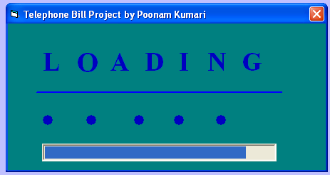

INPUT AND OUTPUT SCREEN

2. LOGIN FORM
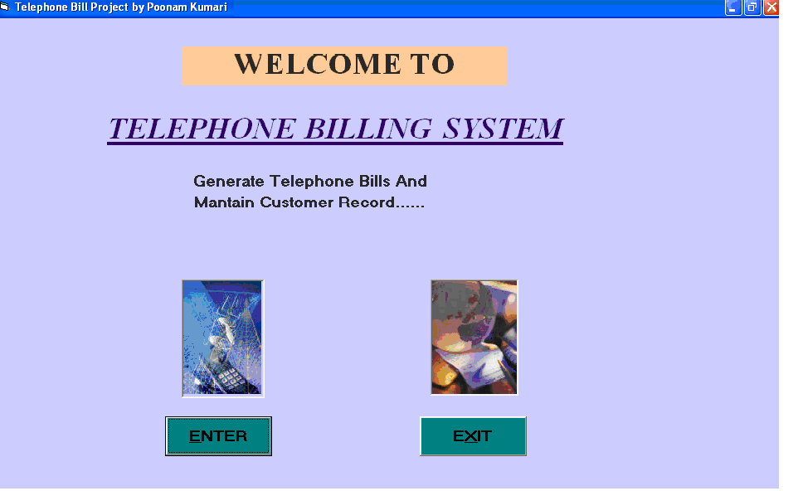

INPUT AND OUTPUT SCREEN

3. WELCOME FORM

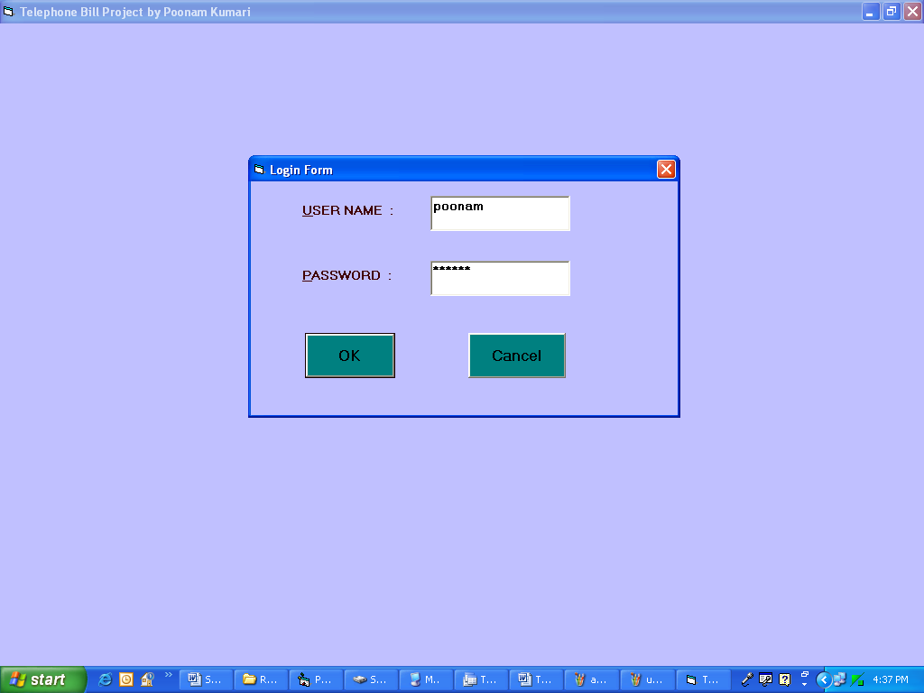

INPUT AND OUTPUT SCREEN
4. MDI Form

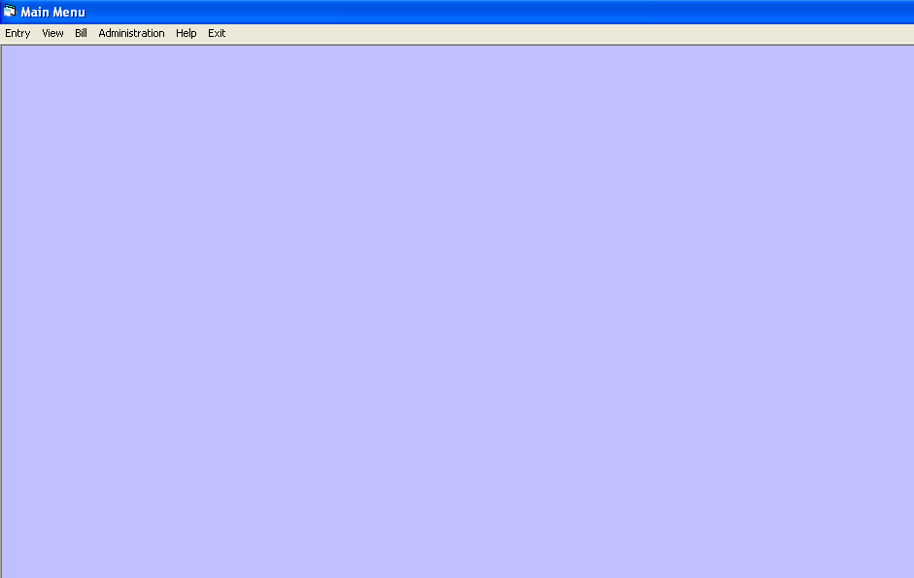
INPUT AND OUTPUT SCREEN
5. ENTRY FORM
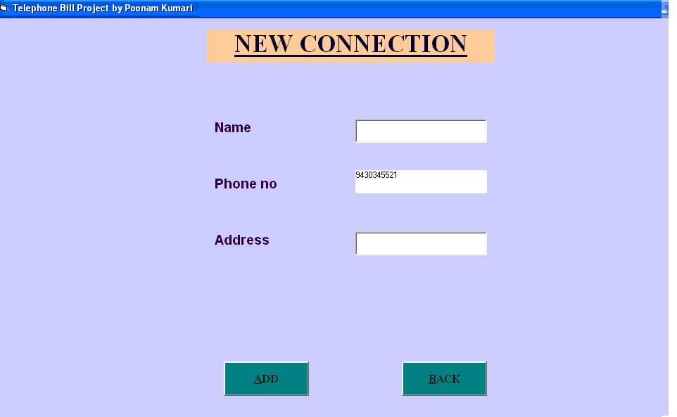
INPUT AND OUTPUT SCREEN
6.CUSTOMER RECORD VIEWING FORM
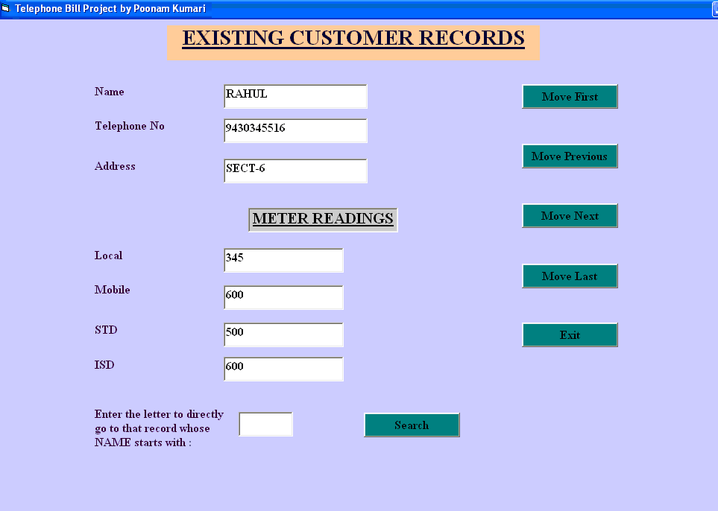

INPUT AND OUTPUT SCREEN

- CUSTOMER BILL CALCULATION FORM

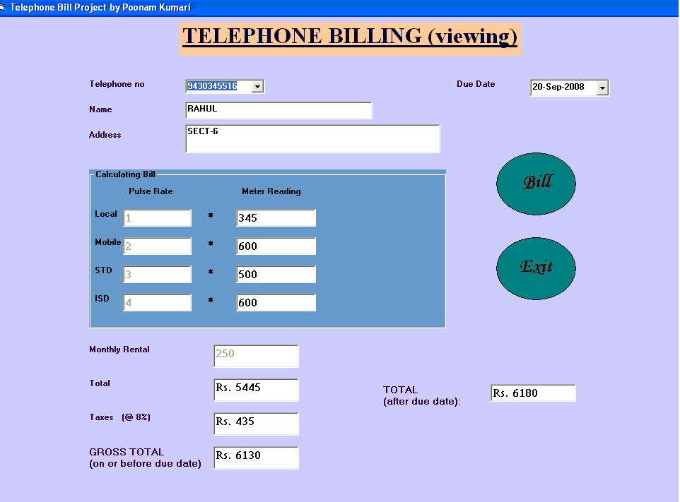

INPUT AND OUTPUT SCREEN

8. ADMINISTRATIVE FORM
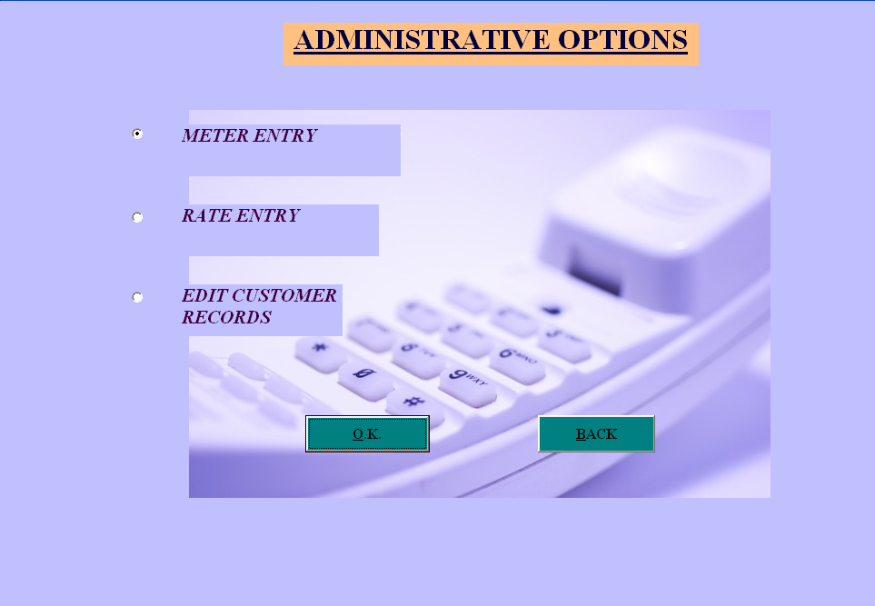

INPUT AND OUTPUT SCREEN
- METER READING FORM

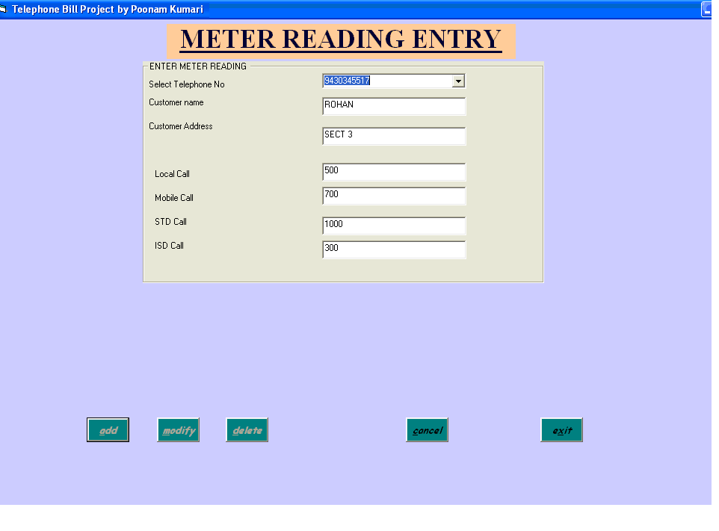
INPUT AND OUTPUT SCREEN
10. RATE ENTRY FORM
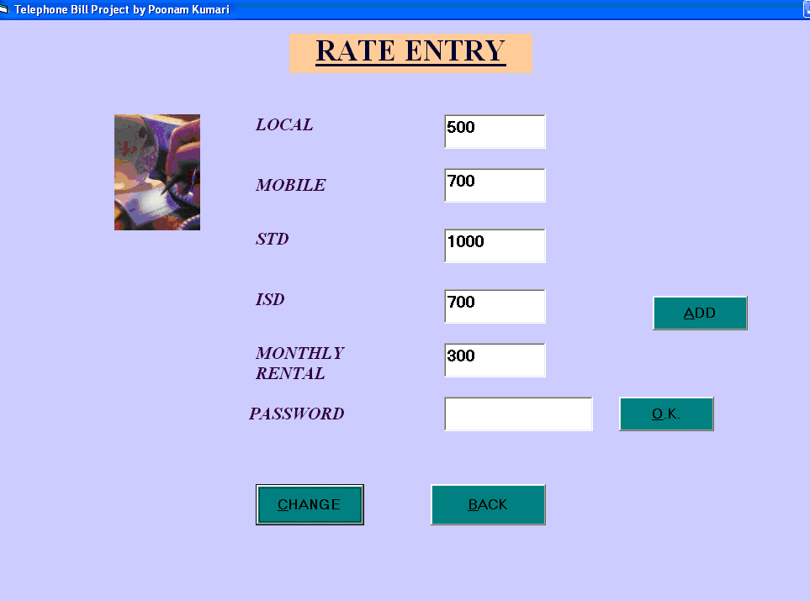

INPUT AND OUTPUT SCREEN
11. CUSTOMER RECORD MODIFICATION FORM
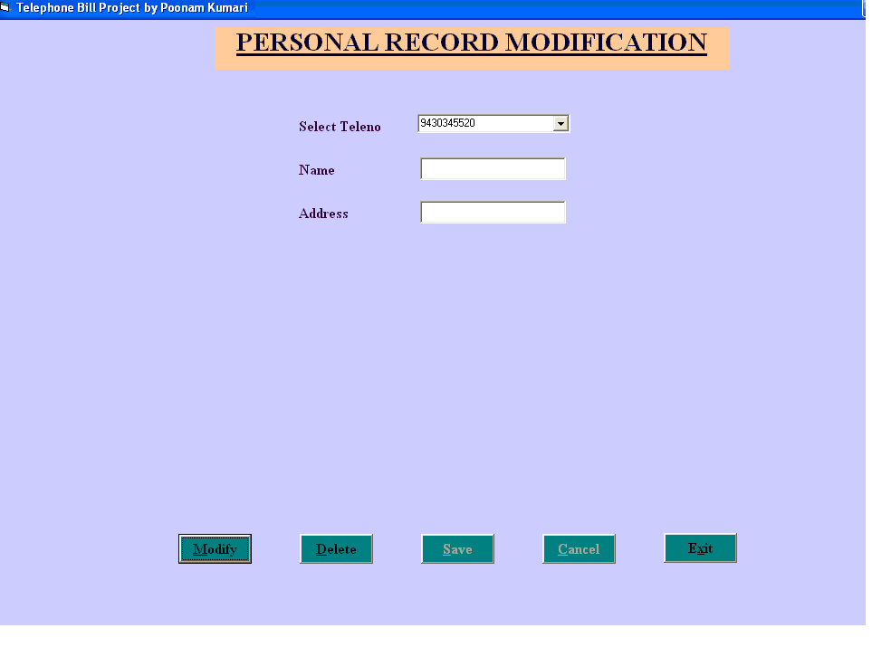

INPUT AND OUTPUT SCREEN

12. HELP FORM

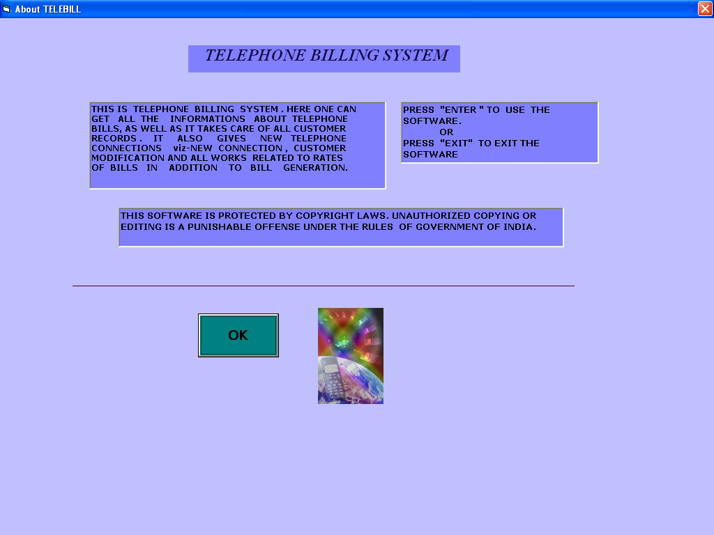

INPUT AND OUTPUT SCREEN

13. BILL REPORT

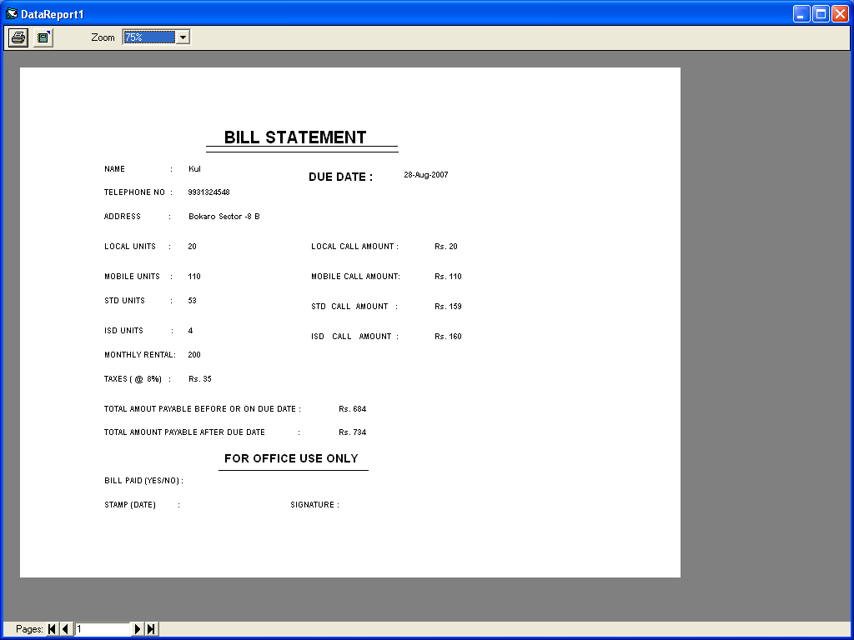

Chapter – 7
Testing & Debugging

7) TESTING AND DEBUGGING

Software testing is a critical element of software quality assurance and represents the ultimate reviews of specification, design and coding. Testing presents an interesting anomaly of the software. During earlier definition and development phases, it was attempted to build software from abstract concept to a tangible implementation.
The testing phase involves the testing of the developed system using various set data. Presentation of test data plays a vital role in system testing. After preparing the test data the system under study was tested using test data. While testing the system by using test data errors were found and corrected. A series of tests were performed for the proposed system before the system was ready for implementation. The various types of testing done on the system are:
- Unit Testing
- Integration Testing
- Validation Testing
- User Acceptance Testing
- System Testing

- UNIT TESTING
Unit testing focuses verification effort on the smallest unit of software design, the module. It comprises the set of test performed by the programmer prior to integration of the unit into larger system. The testing was carried out during the coding stage itself. In this step each module is found to be working satisfactorily as regards to the expected output from the module.

- INTEGRATION TESTING

Integration testing is a systematic technique for constructing the program structure while at the same time conducting tests to uncover error associated within the interface. The objective is to take unit tested modules and build a program structure that has been dictated by design. All modules are combined in this step. The entire program is tested as whole. And chaos in interfaces may usually result. A set of errors is encountered in such a case.

The integration testing can be carried out using two methodologies:

# Top Down Integration

# Bottom Up Integration

The first one is done where integration is carried out by addition of minor modules to major modules. While Bottom Up integration follows combination of smaller ones to large one. Here Bottom Up Integration was encouraged. Even though correction was difficult because the isolation of causes is complicated by the vastness of the entire program, all the errors found in the system were corrected and then forwarded to the next testing steps.

- USER ACCEPTANCE TESTING

User acceptance of a system is the key factor for the success of any system. The system under consideration was tested for users acceptance by constantly keeping in touch with the perspective system user at the time of developing and making changes wherever required. This is done with the regards to the following points:
A system may be defined as a set of instruction combined in the same form and directed to some purpose.
Before any development is undertaken certain specifications are prepared which objectively describe the application system. The System specifications are made after consulting the end user managers of the relevant departments.
Software to be developed is planned on the basis of requirement of the user. The problem definition statement description of present situation and goal to be achieved by news system.

The success of system depends on how accurately a problem is defined, thoroughly investigated carried out through choice of solution. User need identification and analysis that are concerned with what the uses needs rather than what he/she wants. System explains how to perform specific activities or task, which does what and what.

Chapter – 8
Scope & Result Discussion

8) SCOPE AND RESULT DISCUSSION

INTRODUCTION

Even the best system developed has some flaws or others. There always exist scope of further improvement in the system. The effect of implementations of new computerized system is found remarkable.

The following are the major improvement of the new system over the existing system.

- A fully menu driven user-friendly computerized system has been developed where the user can perform task like entering data, deleting and updating the information with great ease.

- All the operations are carried automatically preventing a lot of manual work.

- Additional checks have also been incorporated into the system to avoid duplications of data as far as possible.

SCOPE FOR FURTHER IMPROVEMENT

Every project whether large or small has some limitations no matter however diligently developed. In some cases limitations is small while in other cases they may be broad also. The new system has got some limitations. Major areas where modifications can be done are as follows:

- Our system is not online so further it can be improved.

- The security is limited so some additional arrangement could be made to provide more security to the system.

- There is no provision of complain handling so further it can be added.

MAIN ACHIEVEMENT OF THE SYSTEM

This project gives an overview of the Telephone Billing System.
After entering into the project, user is left with several options via –

- The user can take new connections.

- The user can view the existing lists of customers, which already have telephone connections.

- The user can of course see bills & take billing statements.

- The user can also do several administrative works like managing rates of calls, addition or modification of metered calls & customer entries.

It is a computerized system, which can be used very easily & effectively by the administrators of the telephone billing system.

Chapter – 9
Bibliography

BIBLIOGRAPHY

The great help from our faculty members and my project guide that led the successful completion of the project. Besides that, I took the help of some books and websites to develop the project. They are : --

1. VISUAL BASIC BLACK BOOK
--- Steven Holzner

2. MASTERING VISUAL BASIC 6.0
---- Evangelos Petroutsos

SITES :

- www.a1vbcode.com
- www.google.co.in

